Lab Report

Part-1

**Title:**

1. **Statement of the Problem:**

Make a network using switch and hub.

1. **Hypothesis:**

Sending message from one pc to another pc with the help of hub and switch.

1. **Materials:**

* 6 Pc
* Switch
* Hub

**4. Procedure:**

**1**. At first we implement the Cisco Packet Tracer Software by opening a new file.

**2.** Then we take 6 PCs, a 2960 switch and a hub. We take three PCs in the left side with connecting hub and in the right side the three PCs connected into Switch .we use copper straight wire .At last we connect hub and switch.

**3**. Now we will set the IP address to the PCs along with subnet mask. We will give all the PCs a class C IP address.

**4.** After waiting for some time we will notice the indicating light turn green.

**5.** Then we will switch from real time mode to simulation mode.

**6**. We take simple PDU to transfer from 1 computer to another. And click on Auto Capture / Play button to see how the message transfers. We can also observe the simulation step by step by click on the button Capture / Forward.

1. **Results :**

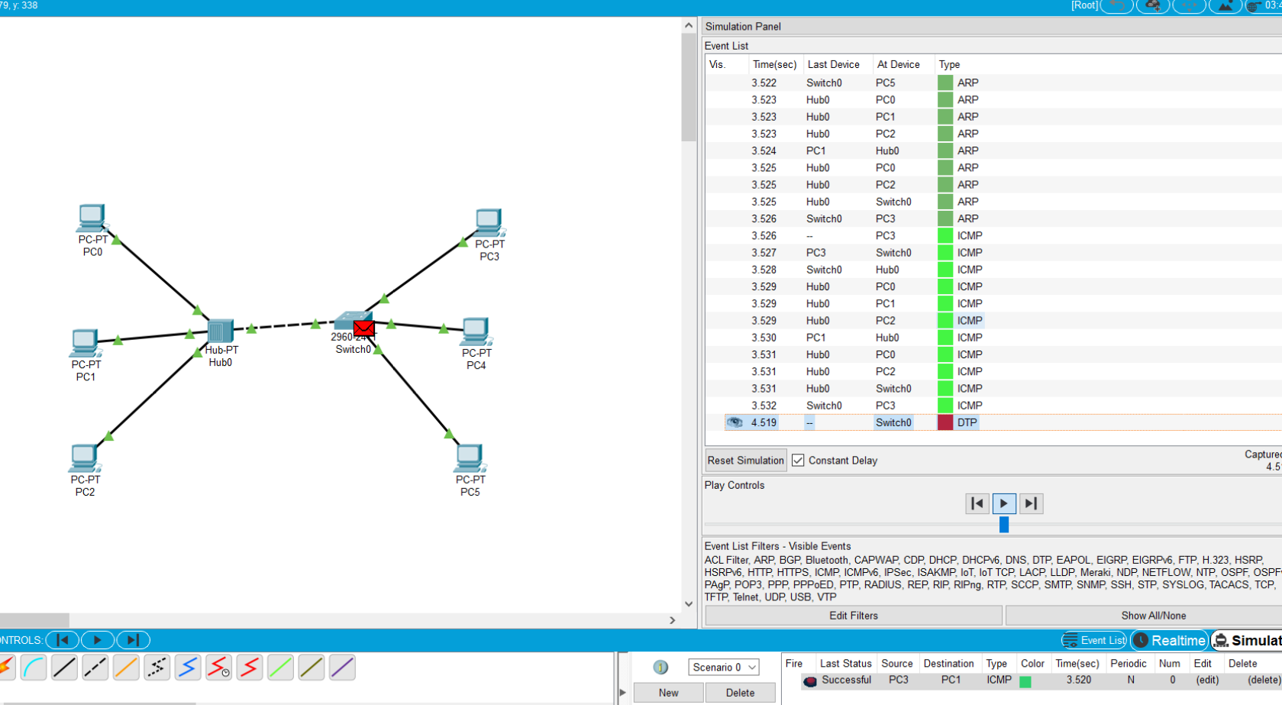

**6. Conclusions:**

1. While configuring the pc we have to be very careful with the IP addresses.
2. We can ping the IP address in the command prompt to check whether the packet is sent from one pc to other or not.
3. If the packet is sent successfully we can continue our experiment successfully

Part -2

**Title:**

**1.Statement of the Problem:**

Make a network using wireless router

**2.Hypothesis:**

Sending message from one pc to another pc by creating wireless connection

**3.Materials:**

* 2 TabletPc
* Router

**4.Procedure:**

**1**.We design the following wired LAN with the help of packet tracer.

a.We take 2 Tablet PC and a switch

b.We connect those 2 pc with the help of copper straight wire to the switch.

**2**.For the wireless connection we take a wireless router and tow wireless device (tablet) like the figure.

a.From the wireless router configuration tab we click in to wireless option and set authentication to WEP

b.We set a new password.

c.In the device settings, from the configuration tab we click to on the wireless option then we select the WEP option and set key.

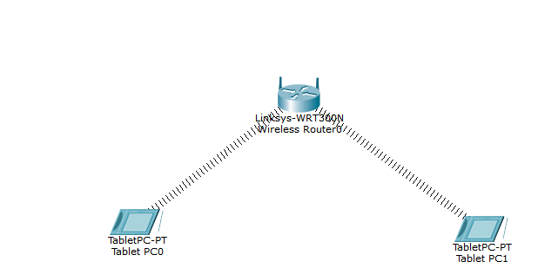

**Fig: wireless LAN with WEP security.**

**5.Results (Data):**

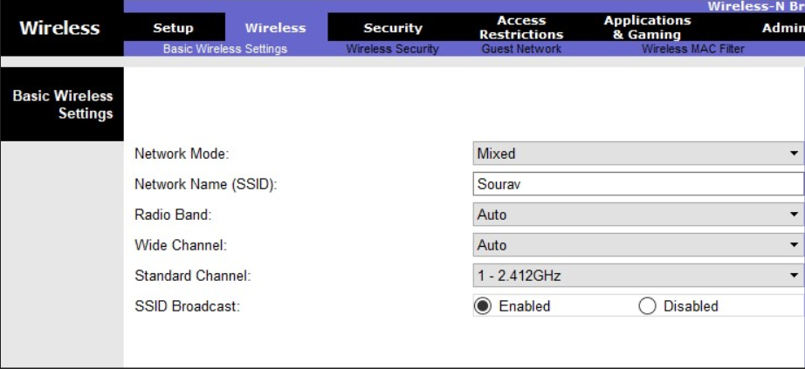

Figure 2: Set the network name.

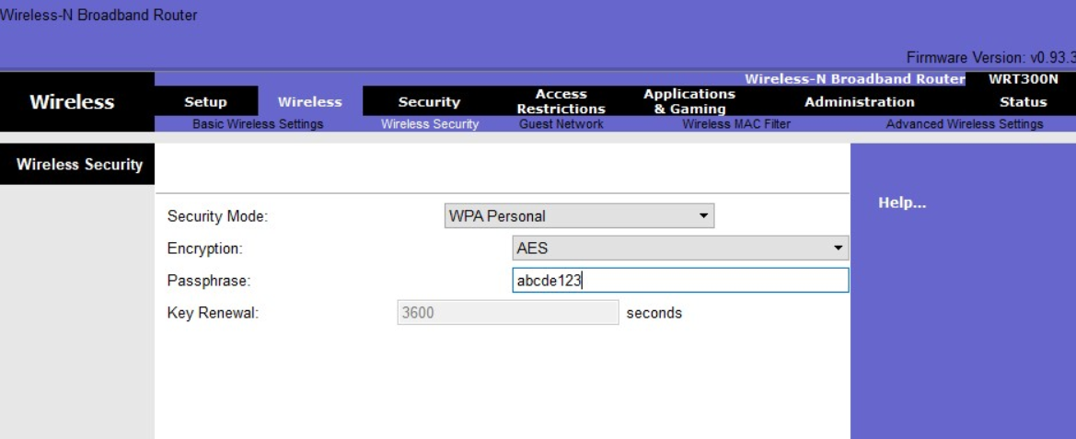

Figure 3: Protect the network with a password.

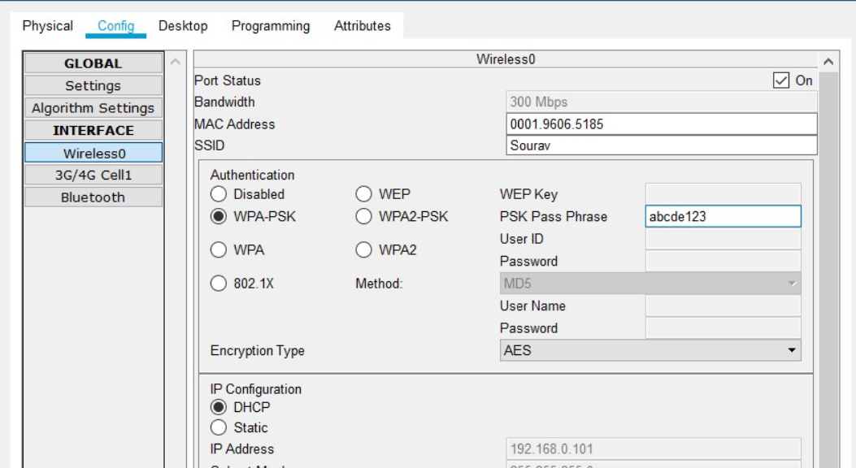

Figure 4: Connection scheme of pc0 and pc1

**We simulate data by sending packets for the wireless LAN in figure,**

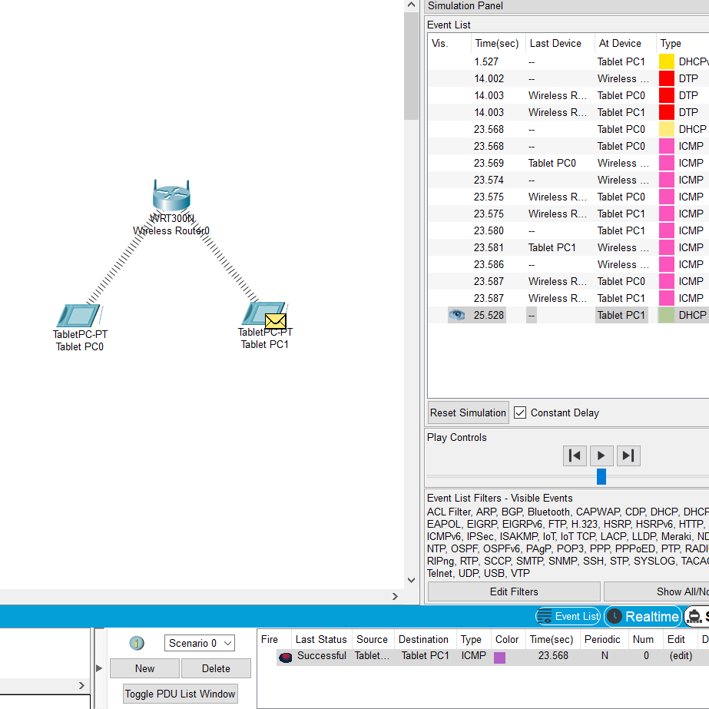

**6.Conclusions:**

1. While configuring the router we have to be very careful with the wireless security.
2. We can ping the IP address in the command prompt to check whether the packet is sent from one pc to other or not.
3. If the packet is sent successfully we can continue our experiment successfully.